HOTEL BOOKING FORM

First time Guest : □ YES □ NO

Guest Name :
Passport No. :
Check in date :
Flight details / ETA :
Email Address :
Contactable Mobile Number :
Have been or transited in India for the past 14 days : □ YES □ NO
ACCOMMODATION

Room Type |  | Full Board
 | Classic Room | IDR 19.388.888 Net
 | Classic Room with Terrace (Smoking Room) | IDR 26.388.888 Net
 | Executive Suite | IDR 54.388.888 Net

Inclusions:
- 7 nights’ accommodation (single occupancy)
- Daily in-room breakfast, lunch and dinner
- Airport representative assistance
- Complimentary airport picks up to hotel
- Complimentary 5 pieces of laundry per day
- 2 x PCR tests in hotel
- Additional person is chargeable at IDR 8.470.000 Net
- The above rates are inclusive of 21% government tax & service charge
PAYMENT
□ Credit Card (By secure payment link)
□ Bank Transfer

*Full prepayment should be receive before guest arrival

Should you have future reservation at any other IHG hotels, you may log in to our website www.ihg.com. Thank you for choosing InterContinental Hotels
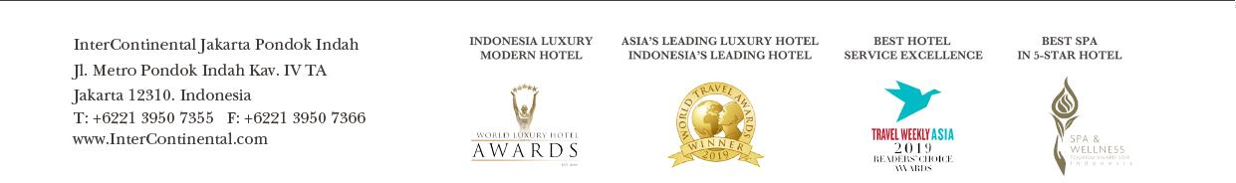
THANK YOU FOR THE RESERVATION AND WE LOOK FORWARD TO WELCOMING YOU TO THE HOSPITALITY OF INTERCONTINENTAL JAKARTA PONDOK INDAH

